REACTIVATION FORM FOR EXISTING PATIENTS

Welcome back to Flack Family Chiropractic!
We’re so glad you’ve chosen to return to us for your care. Because your body and nervous system are always changing, it’s important for us to understand anything new that may have happened since your last visit. If you’ve noticed any shifts in how you’re feeling—or if you’ve had any recent accidents, injuries, stressors, or changes in your daily routine—please let us know below. Even small details can help us tailor your care and support your healing at the highest level. Thank you for taking a moment to update us. We’re honored to continue caring for you and your family.

Name ____________________________________________________________________ Date _____________________
Street Address City: _________________________________________________________________________________
City: ____________________________________________ State: __________ Zip: ______________
Mobile Phone: _________________________________________ Home Phone: _____________________________

Please list any out-of-the ordinary pains, discomforts, or other symptoms you have experienced since your last visit:
__________________________________________________________________________________________________________________________________________________________________________________________________________________________________________________________________________________________________________________

What have you done to try to relieve your symptoms?
__________________________________________________________________________________________________________________________________________________________________________________________________________________________________________________________________________________________________________________

Please list any falls, accidents, or other injuries you have had since your last visit:
__________________________________________________________________________________________________________________________________________________________________________________________________________________________________________________________________________________________________________________

Please list all current medications, including dose and reason for taking.
____________________________________________________________________________________________________________________________________________________________________________________________________________
______________________________________________________________________________________________________
Please continue on the back.
Please list your top 3 health goals:
__________________________________________________________________________________________________________________________________________________________________________________________________________________________________________________________________________________________________________________

Please mark areas of pain or injury on the illustrations below:

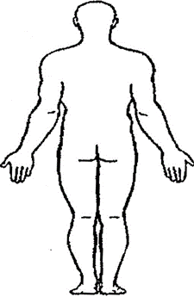
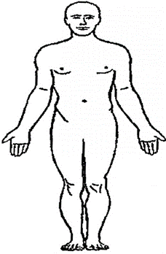

Patient Signature: _________________________________________________________ Date: __________________

